**Report:** **E-commerce Order Fulfillment & Delivery Analytics**

**Background**

FastCart, an online retailer specializing in consumer goods and electronics, implemented Oracle NetSuite ERP to manage sales, inventory, and logistics. However, the company faced significant challenges due to:

• Delayed deliveries, leading to customer dissatisfaction.

• Inefficient tracking, making it difficult to monitor order fulfillment performance.

• Lack of real-time analytics, preventing data-driven decision-making.

To address these issues, FastCart decided to integrate its ERP system with a cloud-based data warehouse (Amazon Redshift) and use Power BI for advanced analytics.

**Work Flow**

**Database Creation**:

* Created a database ‘ecommerce2’ in MYSQL Workbench.
* Table definitions are given in ‘Dataset_Ecommerce.xlsx’.
* There is total 6 tables in the sheet I created a new table products.

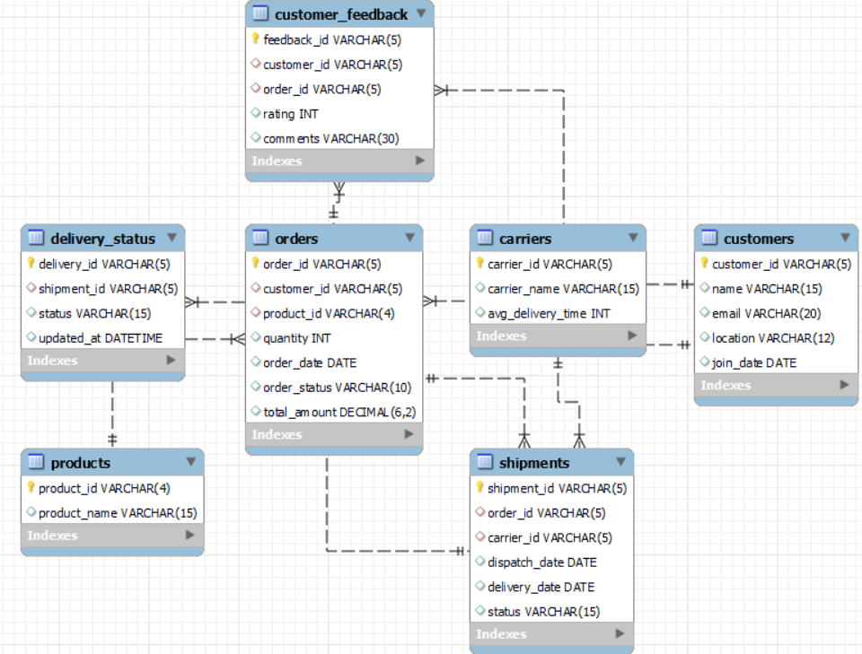

* Customers, products, carriers, orders, shipments, delivery_status and customer_feedback are the tables.
* For inserting the data I have made some assumptions.

1. Products – 5
2. Customers - 7
3. Carriers – 5

* I inserting the data of 15 orders.

**Data Analysis Using Python Pandas**

* Now I have connected the python and database tables using sqlalchemy library using engine.
* Load the database tables into Dataframes using pandas.
* Dispose the engine to close database connection.
* **Order Processing Time** (order placement to shipment dispatch).

1. Formatted date columns in orders and shipment dataframes.
2. Merged the orders and shipment dataframes based on orders_id column.
3. Calculated the time difference between Order_Date and Dispatch_Date and saved it in ‘processing_time’ column.

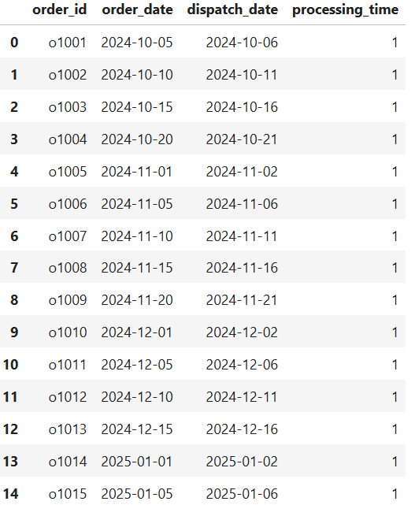 Findings: the processing_time is 1 day for all orders.

* **On-Time Delivery Rate** by analyzing late vs. on-time shipments.

1. Merged the carriers and shipment dataframes based on carriers_id column.
2. Excluded rows where status of shipment is canceled.
3. Findings: 3 rows are excluded.
4. Calculated Actual_Delivery_Time by difference between Delivery_Date and Dispatch_Date.
5. Compared Actual_Delivery_Time with Avg_Delivery_Time to determine if a shipment was on time.
6. Calculated the percentage of on time delivery.

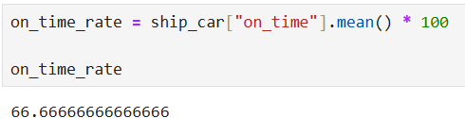 Findings: on time delivery rate is 66.67%.

* **Carrier Performance** based on average delivery times.

1. Used the merged dataframe of carriers and shipment.
2. Grouped by Carrier_Name and Actual_Delivery_Time columns.
3. Calculated mean and rested the index.

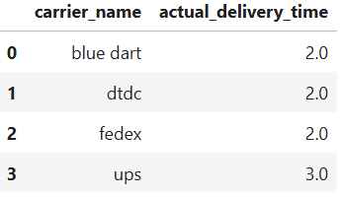 Findings: lowest average delivery time meaning it is the fastest carrier. Blue dart, dtdc and fedex are fastest carriers.

* **Customer Feedback** to identify key service improvement areas.

1. Considered the feedback dataframe.
2. Grouped by ratings column and named column as count.

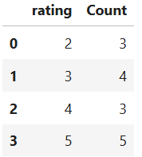 Findings: rating 5 and 4 are considered as positive feedback. Overall the feedback is on positive side.

**Analytics & Reporting (Power BI Dashboards)**

* The 7 Tables in MYSQL Workbench are loaded into power query for transformation.
* The data types are changed for ID columns from number to text as there is no need of performing mathematical calculations.
* After transformation data is loaded into report.
* Goto Model view and check the relationships.

Findings: I have checked the relations they are correctly established.

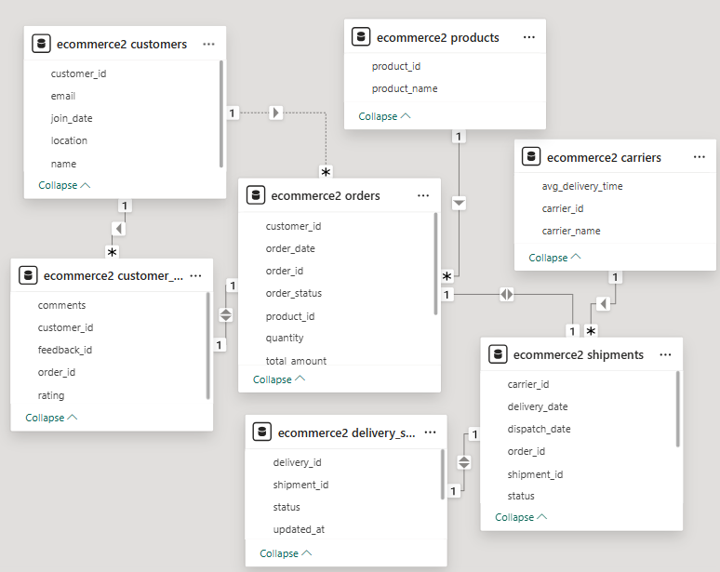

* I added title ‘E-commerce Order Fulfillment & Delivery Analytics’ using text box.
* Created measure ‘**total orders’** under ecommerce2 orders table. Displayed using card visual.

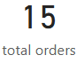 Findings: total number of orders done is 15.

* Created measure ‘**total shipments’** under ecommerce2 shipments table. Displayed using card visual.

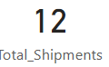 Findings: total number of shipments done is 12. Canceled orders are not considered.

* Created measure ‘**total deliveries’** under ecommerce2 delivery_status table. Displayed using card visual.

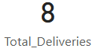 Findings: total number of deliveries done is 8. Canceled and in transit orders are not considered.

**Order Processing Time** – Measures efficiency of order fulfillment.

* Created measure ‘**Avg_Order_Processing_Time’** under ecommerce2 orders table.
* calculated the difference in days between Order_Date and Dispatch_Date.
* calculated the average processing time across all orders.
* Displayed using card visual.

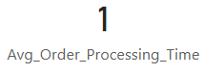 Findings: the average order processing_time is 1 day.

**On-Time Delivery Rate** – Tracks percentage of timely shipments.

* Created measure ‘**On_Time_Shipments’** under ecommerce2 shipments table.
* by finding difference between Delivery_Date and Dispatch_Date. Compared this with Avg_Delivery_Time to determine if a shipment was on time.
* Created measure ‘**On_Time_Delivery_Rate’** under ecommerce2 shipments table. By dividing On_Time_Shipments and total shipments.
* Displayed using card visual.

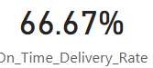Findings: on time delivery rate is 66.67%.

**Carrier Performance Dashboard** – Evaluates logistics partners' efficiency.

* Created measure ‘**Actual_Delivery_Time’** under ecommerce2 shipments table.
* by finding difference between Delivery_Date and Dispatch_Date.
* Displayed carrier_id, carrier_name, Actual_Delivery_Time and On_Time_Delivery_Rate using table visual.

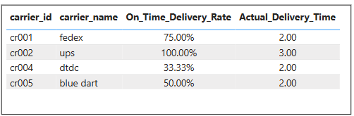

* Findings: on time delivery rate for **ups** is 100%.

**Delivery Delay Analysis** – Identifies common causes of shipment delays.

* Created measure ‘**Cancelled_orders’** under ecommerce2 delivery_status table. Displayed using card visual.

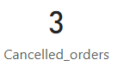 Findings: total 3 orders are cancelled.

* Created measure ‘**Pending_shipment’** under ecommerce2 delivery_status table. Displayed using card visual. Considered in transit as status.

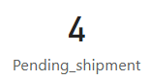 Findings: total 4 delayed shipments.

**Customer Satisfaction Score (CSAT)** – Assesses customer experience.

* Plotted total orders and comments using clustered column chart.

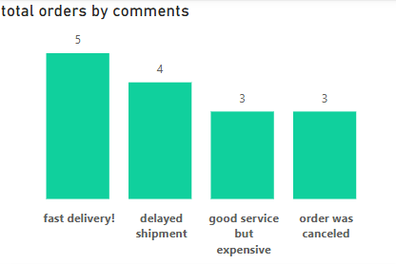 Findings: total 5 orders are fastly delivered. 3 orders were expensive according to customer.

**Total_Revenue by product –** plotted using area chart.

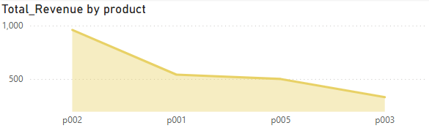Findings: highest revenue generated is from P002.

**Total_Revenue by customer –** plotted using clustered bar chart.

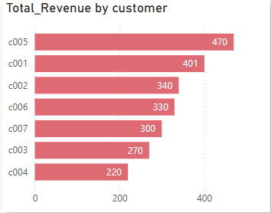Findings: highest revenue generated is from C005.

**Total_Revenue by location –** plotted using waterfall chart.

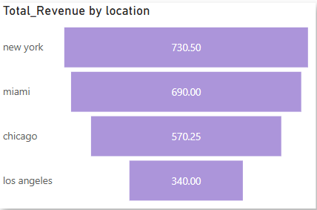

* Findings: highest revenue generated is from New York.
* Created slicer for product to filter all the visuals.

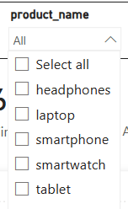

* Created slicer for customer to filter all the visuals.

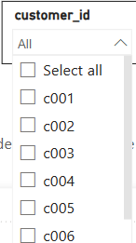

**Complete Report**

